JUST Training Fiche: An unconventional guide to office life

Title | An unconventional guide to office life
Keywords | Organisational hierarchies, Communication
Provided by | IHF
Language | English
Objectives | The objectives of this module are to introduce the concept of organisational hierarchy and its most typical frameworks (including their pros & cons), to explain the Pyramidal Principle of communication that enables a more impactful and effective business communication, and to explain how to better structure the message content when sharing knowledge and information.
Learning outcomes | - Better understanding of how the communication and exchange of inputs flow within an organisation  - Understanding the pros and cons of each of the most typical business hierarchies
Training Area | Business Etiquette | X
 | Digital Skills
 | Soft Skills
 | Smart Working
Content index | An unconventional guide to office life  Unit 1: Valuing and recognising your role in an organisation  Section 1: An introduction to organisational hierarchies  Section 2: Why such kind of hierarchies exist: pros & cons  Unit 2: Shaping your sixth sense  Section 1: Understanding and decoding common non-written office rules
Training content | An unconventional guide to office life  Unit 1: Valuing and recognising your role in an organisation  An introduction to organisational hierarchies  The hierarchal structure of organisations provides insights into:  - The information flows within the organisation (i.e., the decision-making process)  - The perimeter of responsibility/roles of each of the given person involved  Understanding the hierarchal structure of the organisation is of great importance for the new employees as it helps him/her better understand how the chain of command works and who are the people (and functions) to which he/she responds.  Managerial literature and practice offer seven prototype models of hierarchal frameworks.  Please note that some of these frameworks can co-exist within the same organisation, depending on, for instance, the size of the company, number of employees, markets covered and diversification of services/products provided, and overall, the general complexity of the organisational chart.  Pyramidal Org. Structure  Typical of public organisations, the pyramidal organisation structure is the most common form of hierarchy that you will experience in your professional career.  The chain of command is very much streamlined: inputs come from the above, and the lower the level, the lower the responsibilities, and the lower the decision-making faculty.  People at the “officer” level perform tasks and activities that pertain to their specific area of interest only (i.e., finance) and respond to their director exclusively.  Illustrative example:  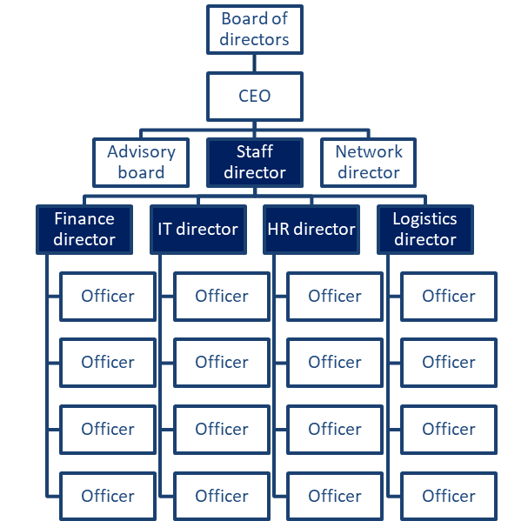  Functional Org. Structure  The functional org. structure works similar to the pyramidal framework.  Indeed, most of times, pyramid structures are further break down into functional arrangements so as to favor a more granular visualization of the chain of command and the people in charge of each of the given role – at any given layer.  The assumption is the same: people with higher level of seniority occupy top positions and organize their staff based on specific competences, skills and expertise  Illustrative example:  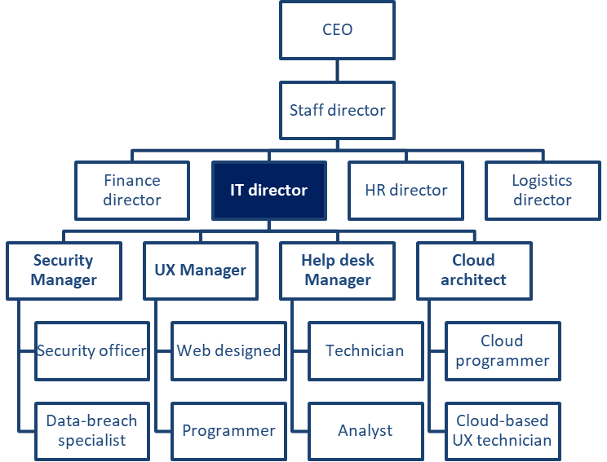  Horizontal / Flat Org. Structure  The horizontal/flat chart is quite common in small organisations or start-up-like companies that, by nature, can afford fewer layers between employees and upper management.  An internal organisation as such is also quite often established among the professional firms’ ecosystem (i.e., lawyers, accountants, architects, etc.) with limited internal diversification of competencies, expertise and responsibilities.  In general, this type of structure works best when the firm/organisation is highly specialised in a limited number of products/services – hence there is no need to establish further departments.  Illustrative example:  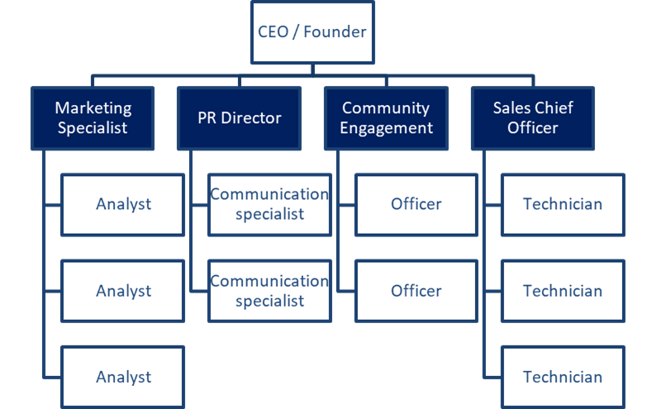  Divisional Org. Structure  Slightly more complex compared to the others, the divisional org. structure takes into consideration the company’s breakdown into its fundamental divisions, each of which operates like a “firm within the firm”.  Each division represents a specific strand of the many businesses one organisation might be involved in.  This structure is fairly typical of medium-large consulting companies and other businesses operating at the same time in more than one field.  It is common that each division has its own marketing, accounting, IT, HR, etc., executive teams so as to favour great autonomy and self-dependence.  Illustrative example:  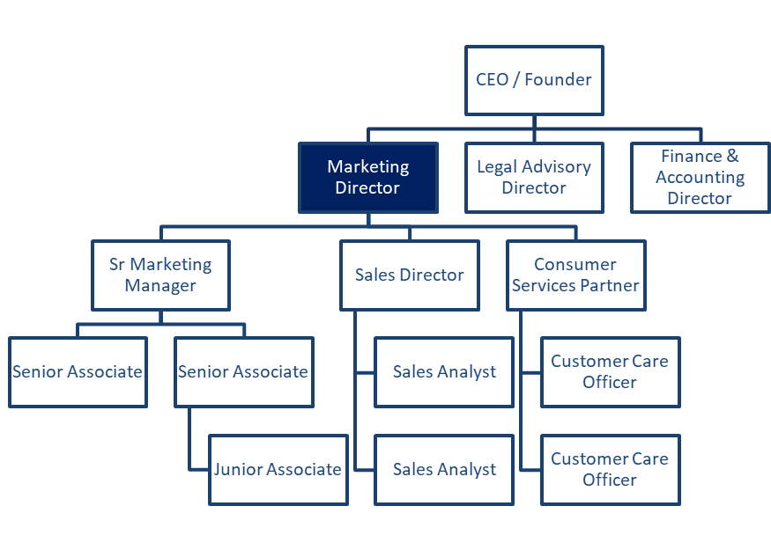  Divisional Org. Structure: few variants  Market-based org. structure  The divisions are separated based on the different industries/markets occupied by the firm or the customers served.  Examples:  - Division 1: gluten-free  - Division 2: vegan  - Division 3: bio  - …  Product-based org. structure  The divisions are separated based on the different product/service lines offered by the firm.  Examples:  - Division 1: Coca-Cola  - Division 2: Fanta  - Division 3: Sprite  - …  Geo-based org. structure  The divisions are separated based on the geographic markets served by the firm.  Examples:  - Division 1: North America  - Division 2: South-Europe  - Division 3: Balkans  - …  Matrix Org. Structure  A matrix organisational structure comes into place in very specific circumstances, and it is usually adopted to show how cross-functional teams collaborate to carry out projects that are limited in time. In this case, people will find themselves responding to other teams and other departments that are not, as per the traditional organisational chart, responsible for their work and delivery.  Matrix structures are fairly more challenging to manage due to the higher complexity that comes with managing such a diverse cohort of expertise, know-how, expertise and, nonetheless, expectations, work attitudes and experience.  Illustrative example:  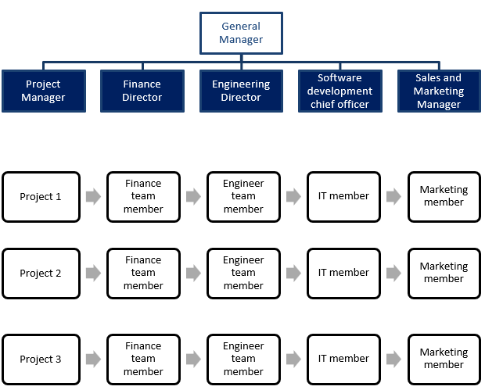  Team-based Org. Structure  Again, very common in a small organisation (i.e., star-up) that provides for a narrow-specialized offer.  As the name implies, the team-based organisational structure breaks down the organisations into teams, more or less cross-functional and diverse in the sense of competencies involved.  Team-based structures are meant to streamline operations, flatten the hierarchies within the organisation and give employees more control over the tasks/activities they are responsible for…  Illustrative example:  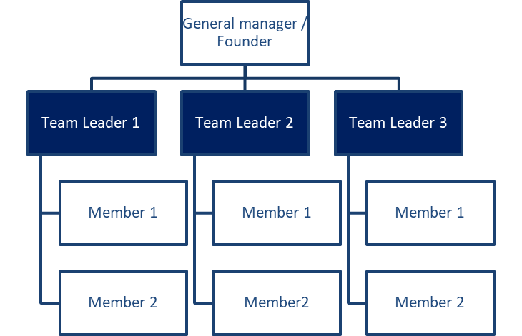  Network Org. Structure  Without any doubt, the most complex framework that is applied to a firm structure.  Very trendy and in vogue among large multinational organisations, the network organisational structure implies the very reframing of the hierarchy concept as normally understood and conceived.  The network structure fragments the organisation into a macro-cluster of functions more or less dependent on one another. Each cluster can be organised following one of the many frameworks analysed already or a hub itself of a further sub-network.  Example:  ROMANIA: Production Assembly  ITALY: Manufacturing  GERMANY: Finance Administration  FRANCE: Legal  Why such kind of hierarchies exist: Pros & Cons  In the next section, we will go through common pros and cons recognised both by literature and practice associated with each of the previous frameworks.  This will help you better understand:  - What might be common and practical implications for you  - What is your place  - What can you do to disrupt the disruptions  - What are the basic rules of the game you’re participating in  Pros & cons of the Pyramidal Org. Structure  PROS  - Clear decision-making flow  - Perfectly displayed layers of authority and responsibility  - Well-intuitive career path ahead of the employee  - Specialization and diversification of roles (i.e., less fragmentation and dispersion of efforts)  - Well-identifiable chain of command and local control in case of support is needed  CONS  - Isolation from other departments and a sense of alienation from the whole value chain  - High level of bureaucracy with a lower margin of autonomy in decision making  - Overall rigidity and less flexibility in the execution and performance of tasks  - High fragmentation in communication from strategy to execution with a larger margin of errors and misinterpretations  Pros & cons of the Functional Org. Structure  PROS  - Greater specialisation of employees  - Higher sense of ownership for the outputs associated with that given function  - Easily replicable at all levels  - Sense of comrade & discipline  - More robust and reliable sense of self-autonomy  - Less dispersion of energies and efforts within the same functions  CONS  - Risk of too high self-isolation of the given function and loss of systemic focus  - Hampering cross-functional dialogues with negative impacts on knowledge flow  - Overall rigidity and risk of loss of locus of control/understating of the sub-functions within the same technical field  - Higher fragmentation at the horizontal dimension  Pros & cons of the Horizontal / Flat Org. Structure  PROS  - Greater opportunities for knowledge exchange  - Quicker and leaner information flow  - More comprehensive awareness of the function of the business  - Solid and robust understating of the overall value chain and how the inputs from each of the functions contribute to the generated value for the business and the people involved  - Higher sense of ownership  CONS  - Higher risk of entropy due to the lack of a centralised locus of control (or a well-identified supervisor to which to report)  - Fewer opportunities for specialisation  - Greater risk of disruptions impacting the whole business due to the inefficiency/ineffectiveness of a specific function  - Sustainable only for small companies and relatively limited fields of application overall  Pros & cons of the Divisional Org. Structure  PROS  - Supports large organisations in remaining relatively flexible  - Helps top management in decentralising the chain of command and containing disruptions without affecting the whole organisation  - Promotes independence and a sense of entrepreneurial attitude at all levels  - Diversify the risk of profitability and the range of industries/markets covered by the firm  - Guarantees for quicker and more efficient business responsiveness to market changes  CONS  - High risk of entropy within the division and headquarter  - High absorption of financial and economic resources that cannot be shared among divisions  - High risk of competition between divisions (i.e., competition for markets’ niches, competition for internal resources, etc.)  Pros & cons of the Matrix Org. Structure  PROS  - Greater dynamism and opportunities for further exchange of knowledge  - Higher participation of field experts and trans-sectorial experience to value generation  - Diversification of capacities, know-how and expertise  - Greater opportunities for a talent-based approach to staffing and recruitment  - Diversification of risk and locus of control for a more balanced approach to quality assurance  CONS  - Risk of conflicts between locus of control due to different “cultural” and professional approaches to project management and the final outputs/outcomes expected by the project  - Turnover in staffing, with consequent slow-downs of the workflow for the other functions – even if not necessarily interested in the staffing dynamics  - Susceptible to changes more than any other framework due to its temporary nature and highly dependent on the given project  Pros & cons of the Team-based Org. Structure  PROS  - Greater knowledge exchange opportunities  - Higher know-how and expertise sharing  - Diversification of skills and competencies of employees  - Promotes later career opportunities  - Increased responsiveness of the whole organisation to any given change might be needed  - Streamlining of communication  CONS  - Very challenging to sustain whenever differences in work approaches arise (very likely nonetheless)  - Reduced clarity of the chain of command and decision-making flow overall  - In general, not sustainable for companies highly diversified in the products/services provided and markets/industries covered  - Higher risk of entropy  Pros & cons of the Network Org. Structure  PROS  - Helps large organisations better visualizing the complex nature of their structure  - Sustain employees and stakeholders with a better understanding of the locus of control, workflow and the group of people behind each stage of the value-generation process  CONS  - Fairly complex to manage and keep under control, specifically when a large portion of the value generation process is decentralised  - Greater difficulties for lower-level employees in understating the source of certain directives / who’s really responsible for certain issues and concerns  Unit 2: Shaping your sixth sense  Understanding and decoding common non-written office rules  Far from common social media propaganda, offices are very “complex” social ecosystems at times very difficult to navigate through. There are indeed numerous unwritten rules that you familiarise yourself with only when you find yourself in certain scenarios.  In the next paragraphs, you will be introduced to a couple of life buoys that for sure will help you in preventing unpleasant scenarios… These relate to:  - Communication  - Common sense  About Communication  If something is not clear, make it clear…  Do not be afraid to ask questions: be sure that all the information is well-understood from your side.  First thing first  Any expected output from your side that is the input of somebody else’s workflow must be your priority.  Be straightforward  Do not waste your time for the sake of buying time: take action.  Wait for your turn  Are you sure that what you are about to say provides for any contribution to the discussion and is worth anybody else attention?  Make a step back and do the math  Are you sure that what you are about to say makes sense?  Be concise and comprehensive  There is only a limited amount of information that our brains can process at any given time.  About Common sense  Never commit to what you cannot guarantee in time and in quality  People remain impressed by the quality of your work, not necessarily the amount – even more so if this comes at the costs of the previous…  No superheroes allowed  When in difficulty, just say it.  Do not over-complicate things  Find a way to keep things simple & smart.  Observe and keep a record of what made an impression on you  ..for the worst or for the better.  Play the game by the book…kind of  Make sure to perform the task as per the guidelines’ assignment, but do not be afraid to experiment with suitable alternative ways of doing things (if contribute to generating value).  Do not force fake positivity on yourself  There is nothing worse and more irritating than fake and forced behaviours.  Summing up  7 common types of organisational hierarchies  Each of which with specific pros and cons  Hacks for common sense and Communication  Basic principles to make your life a bit easier…
Glossary | Organisational hierarchies: The hierarchal structure of organisations provides insights into how:  - The information flows within the organisation (i.e., the decision-making process)  - The perimeter of responsibility/roles of each of the given person involved
Self-evaluation (multiple choice queries and answers) | 1. The pyramidal framework of hierarchy:  - Is the most complex to manage.  - Is typical of public organisations.  - It is no longer common in practice.  2. The horizontal framework of the hierarchy:  - It is recommended for large organisations to reduce internal complexity.  - It implies a peer-to-peer relation across all levels.  - It is most common and recommended for small and agile organisations.  3. The format of the communication relates to:  - The way the content is introduced and presented to the interlocutor.  - The relevance of the content.  - The clarity of the message.
Bibliography
Resources (videos, reference link)

